**INDUSTRIAL QUANTUM ROBOT**

**WEEK - 9**

**KAVIN KISHORE S G**  **7376221CS191**

1. Move along the X-direction

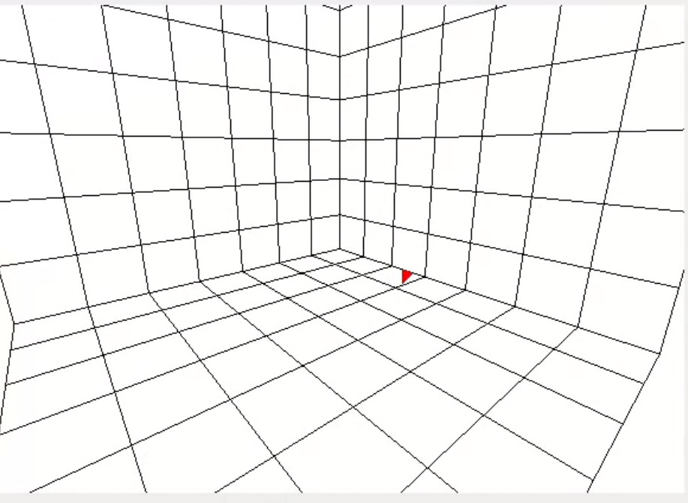

1. Move along Y-direction

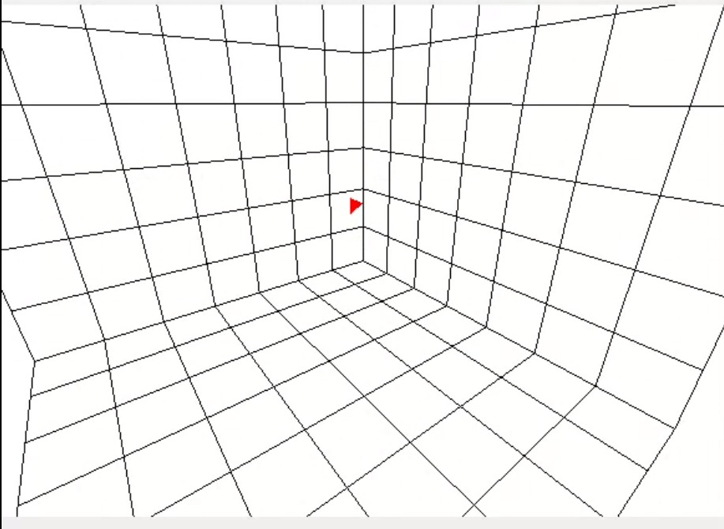

1. Move along the Z-direct

